**CREATING FILE :**

package module8;

import javax.xml.parsers.*;

import java.io.*;

import org.w3c.dom.*;

import javax.xml.transform.*;

import javax.xml.transform.dom.*;

import javax.xml.transform.stream.*;

public class CS2 {

public static void main(String[] args) {

DocumentBuilderFactory f = DocumentBuilderFactory.newInstance();

DocumentBuilder b = null;

try

{

b = f.newDocumentBuilder();

}

catch(ParserConfigurationException e)

{

e.printStackTrace();

}

Document doc = b.newDocument();

Element rootele = doc.createElement("employees");

Element employeeele = doc.createElement("employee");

Element idele = doc.createElement("id");

Element nameele = doc.createElement("name");

Element genderele = doc.createElement("gender");

Element salaryele = doc.createElement("salary");

Element addressele = doc.createElement("address");

Text t1 = doc.createTextNode("001");

Text t2 = doc.createTextNode("Tanuja");

Text t3 = doc.createTextNode("Female");

Text t4 = doc.createTextNode("100000");

Text t5 = doc.createTextNode("Warje , Pune");

idele.appendChild(t1);

nameele.appendChild(t2);

genderele.appendChild(t3);

salaryele.appendChild(t4);

addressele.appendChild(t5);

employeeele.appendChild(idele);

employeeele.appendChild(nameele);

employeeele.appendChild(genderele);

employeeele.appendChild(salaryele);

employeeele.appendChild(addressele);

rootele.appendChild(employeeele);

doc.appendChild(rootele);

Transformer t = null;

try {

t = TransformerFactory.newInstance().newTransformer();

}

catch(TransformerConfigurationException e1)

{

e1.printStackTrace();

}

catch(TransformerFactoryConfigurationError e1)

{

e1.printStackTrace();

}

try {

t.transform(new DOMSource(doc), new StreamResult(new FileOutputStream("/home/ubuntu/employees.xml")));

}

catch(FileNotFoundException e)

{

e.printStackTrace();

}

catch(TransformerException e)

{

e.printStackTrace();

}

System.out.println(" XML file generated ");

}

}

**OUTPUT :**

XML file generated

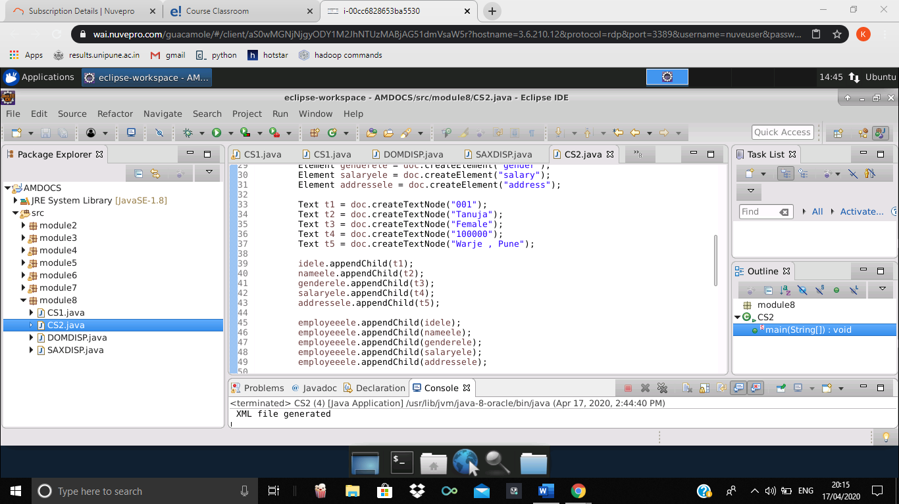

**DISPLAY USING SAX :**

package module8;

import javax.xml.parsers.*;

import java.io.*;

import org.xml.sax.helpers.*;

import org.xml.sax.*;

public class SAXDISP extends DefaultHandler {

public void startDocument()

{

System.out.println("Document starts here");

}

public void startElement(String uri, String localName, String qName, Attributes attrs)

{

System.out.print("<" + qName + ">");

}

public void characters(char ch[], int start, int len)

{

System.out.print(new String(ch,start,len));

}

public void endElement(String uri, String localName, String qName)

{

System.out.println("</" + qName + ">");

}

public void endDocument()

{

System.out.println("Document ends here");

}

public static void main(String[] args) throws Exception{

SAXParser p = SAXParserFactory.newInstance().newSAXParser();

p.parse(new FileInputStream("/home/ubuntu/employees.xml"), new SAXDISP());

}

}

**OUTPUT :**

Document starts here

<employees><employee><id>001</id>

<name>Tanuja</name>

<gender>Female</gender>

<salary>100000</salary>

<address>Warje , Pune</address>

</employee>

</employees>

Document ends here

